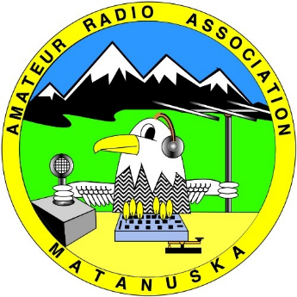
Matanuska Amateur Radio Association
Board Meeting
January 10, 2024

Meeting Called to Order at 7:04pm via Zoom.
Quorum Established – Scott, Ken, Shelia, John C, George, Don, Brandon attended.
Approval of Agenda/Additions motioned by John C, seconded by Ken.

President’s Report: Scott McCormick, KL7SLM
Happy New Year! Wanting an exciting year

Vice-President’s Report: Ken Hudson, KL2HF
Presentation will be POTA by Brandon, plan to have the next three presentations be on how to set up and use our equipment

Treasurer’s Report: John Carrington, KL1XM
General account: $8,564.99 Dues need to be paid and to consider renting storage shed for all the various equipment.
Book account: $764.44 George motioned for Don and John C to sign a 1-year contract for a heated storage unit not to exceed $85/month, Ken seconded, the board approved unanimously.
John C motioned that up to $300 be spent on shelving to be used inside the storage unit, George seconded, the board approved unanimously.

Secretary’s Report: Shelia Olson, KL3SRO
Still working on getting minutes completed, plan to be caught up by January general meeting, getting notebooks compiled for president, vice president, and secretary, newsletter to go out the 21st.

Website Facilitator: Don Bush, KL7JFT
Had an outreach of interest in the club and provided them with lots of information to get them going.

ARES/Repeater Report: Don Bush, KL7JFT
Commex on hold due to no one available to plan, doing annual review of Skywarn, getting new MSB ID cards set up, have $631 from fund raiser, will go one more month.

Trailer Committee: Scott McCormick, KL7SLM
Generator started without any problems even though it was negative temps.

VE Report: Ken Hudson, KL2HF
There were none in December probably due to the holiday time, so far have 1 interested in taking extra exam and 1 for tech exam.

Licensing Classes: John Mears, AL7LA
Not present – last statement was going to be April.

Sunshine Committee: Shelia Olson, KL3SRO
One card going out

Events Planner Shelia Olson, KL3SRO
Next event is Winter Field Day, willing to help however I can.

Old Business
1. Holiday Party – Shelia, Betty decorated earlier than scheduled, had 16 attendees, 12 participated in the gift exchange, plenty of food that we also shared with the church attendees and staff

Ongoing Business
- Update on repeaters, *POC Don/KL7JFT* – nothing new, looking for gems in the valley to connect to.

2. Palmer Junior Middle School, *POC Scott KL7SLM* Ham Club discussed with William, how to set up, what equipment to purchase, their first club meeting will be week of January 16, asking for MARA club members to present trainings and mentor the students, will need 4 licensed operators before they can be a club

3. Winter Field Day, *POC Brandon/KL7BSC* will use his call sign and be an outreach for PJMS students, faculty, and parents, since not enough people to set up both the communication and support trailers

4. Field Day 2024, *POC –* - Can be at the grassy area of the Trunk Road Park and ride parking lot as in previous years, need to get busy so there is enough time to submit paperwork to ARRL

New Business:
Upcoming Events:
1. MARA Luncheon, January 25 @1130 Denali Family Restaurant

2. MARA Hybrid General Meeting, January 26 @1900, Valley Church of Christ

3. Licensing Exams, *POC: Ken KL2HF* January 27 @1900, WASI

4. MARA Board Meeting, February 14, 2024 @1900 WASI/ZOOM??

John C motioned for meeting to be adjourned, George seconded, Ken thirded. Meeting was adjourned.

Respectfully submitted,

________________________
Shelia Olson, KL3SRO, Secretary

