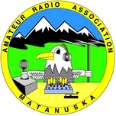
MATANUSKA AMATEUR RADIO ASSOCIATION
AFTER ACTION REPORT
This report is intended to aid in MARA’s process improvement of event planning, operations, policies and procedures. The information that is included in this report may be shared with our severed agencies to assist in their process improvement programs. Please send this form to the MARA point of contact for the event.

Date Prepared:
Prepared by:
Date of Event:
Event Name:
Event Location:
Event Type:
Equipment Used:

Event Description:

Event Timeline:

Summary of Participation and Take Aways:

Recommendations for Improvement:

