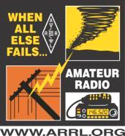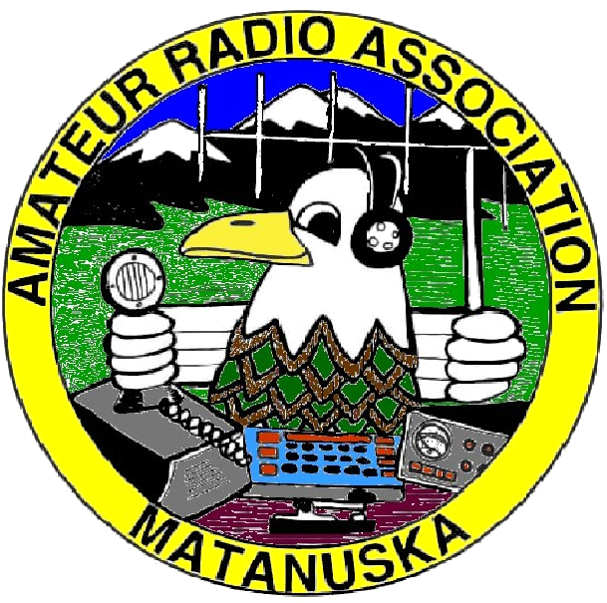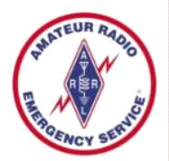

MARA PLANNING QUESTIONNAIRE
2022-2023

Name / Call sign: ____________________________ Phone number: ________________

Email___________________________________________________________________

I WOULD LIKE THE FOLLOWING TOPICS PRESENTED AT THE GENERAL MEETINGS

Topic and
Presenter________________________________________________________________

Topic and
Presenter________________________________________________________________

I WOULD LIKE MARA TO PARTICIPATE IN COMMUNITY ACTIVITIES SUCH AS

____________________________________________________________________________

I WOULD LIKE TO PARTICIPATE / CONTRIBUTE TO OUR HOBBY

Be an Elmer ______ Teach / Present topic_____________________________________

Be a VE ____ Program Equipment ___ Setup / Take down equipment __________

Participate in MARA activities ______ Participate in ARES activities _________________

Other ideas___________________________________________________________________

FUNDRAISING ITEMS I WOULD LIKE CLUB TO CONSIDER

T-shirts _____ Patches _____ Decals _____ Travel Mugs _____ Hat/Lapel Pins _____

Water bottles _____ Bumper sticker _____ Other ideas________________________________

Return to Tabitha Sherman/KL4FZ at tabithainAK@gmail.com or Don Bush at dbush@gci.net or mail to MARA PO Box 873131, Wasilla, AK 99687

