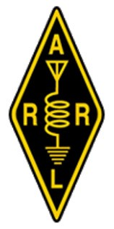
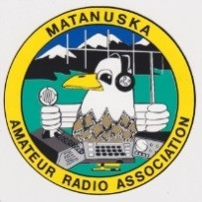
Matanuska Amateur Radio Association P.O. Box 873131
Wasilla, AK 99687-3131 www.kl7jfu.com
Membership Application /RENEWAL
Matanuska Amateur Radio Association, Inc. (MARA) welcomes any honorable, law-abiding applicant interested in promoting amateur radio communications, experimentation, and education. You need not hold an amateur license to be a club member. Your skills and input will help us reach our goals in furthering our hobby. MARA is affiliated with American Radio Relay League and receives assistance from the ARRL. You need not belong to ARRL to join MARA. We do encourage membership in ARRL to support our association’s affiliation. You may sign up for ARRL membership through MARA, so that a portion of your ARRL dues are given to MARA.
MEMBERSHIP TYPE (see page 2)
Regular  Membership: $24/yr | New | Renewal |  | Effective dates: through
Family  Membership: $48/yr  For 2 or more | New | Renewal |  | Effective dates: | through
 | Names & Call Signs of household members: (This includes 1 vote per each family member)
Newly licensed Technician  (complimentary) | Effective dates: through
ARRL (American Radio Relay League) Member? | Yes | No | Date membership expires:
Name: _________________________________________ Call sign: _________________ Class: _____________
Mailing Address _____________________________ City __________________ State_____ Zip Code __________
Physical Address_____________________________________ LAT/LONG or Grid square __________________
Home Phone: ________________ Cell Phone: ________________ Email: _______________________________
I would like to have more information and/or help with: ___ Getting/Setting up my radio ___ Getting on the Air Other: ___________________________________________
My interests are: | Base Station | Mobile | Hand Held
HF / VHF / UHF voice
Digital radio, i.e. Winlink, packet, TV
CW (Morse Code)
DX, QRP, Contesting, Field Day
Electronics / Antennas
Emergency Services/ARES
IF YOU ARE A BRAND NEW HAM, WHEN AND WHERE DID YOUR EARN YOUR LICENSE?
_____________________________________________________________________________________.
Signature____________________________________________________ Date___________________________
Repeater fund donations of any amount are optional and greatly appreciated. . MARA is a 501 (c) (3) corporation. Your donations are tax-deductible.
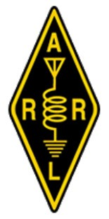
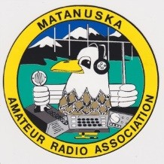
Matanuska Amateur Radio Association P.O. Box 873131
Wasilla, AK 99687-3131 www.kl7jfu.com
Date ____________________________________:
Dear ____________________________________:
Welcome to the Matanuska Amateur Radio Association. Our monthly meetings are on the last
Friday of each month, 7:00—9:00 p.m., meeting usually at Good Shepard's Lutheran Church. Please check the website, kl7jfu.com, for any changes to the normal schedule and to the location. Our FaceBook page is MARA CLUB.
Your membership is effective through ______________________________________________
___________________________________________________ __________________
73, Name / Call Sign Date
Definitions
REGULAR MEMBERSHIP assigns all rights and privileges such as voting on club matters, election of officers, ability to seek club office, offering motions to alter club policies, bylaws, and activity agenda. Each regular (full) membership has one vote in actions of the membership for $24 per year.
FAMILY MEMBERSHIPS are for current active members with dependents (as defined by the IRS dependent standard), if the dependent(s) wish to join. Multiple dependents are allowed under a single current active membership for $48 per year. The family membership allows all privileges for each person, however only members with call signs can vote.
COMPLIMENTARY MEMBERSHIP. Newly licensed Amateur Radio operators are invited to join MARA and are granted a one-year membership with all privileges as for a Regular Membership.
Note: this page goes to the Member.
Repeater fund donations of any amount are optional and greatly appreciated. . MARA is a 501 (c) (3) corporation. Your donations are tax-deductible.

